**Tableau Parts 7 and 8: Exercises with answers**

Exercise 7

1. Import the ‘employee.csv’, ‘department.csv’ and ‘project.csv’ into Tableau. Combine all 3 tables using Relationships by dragging the tables into the canvas.

Answer:

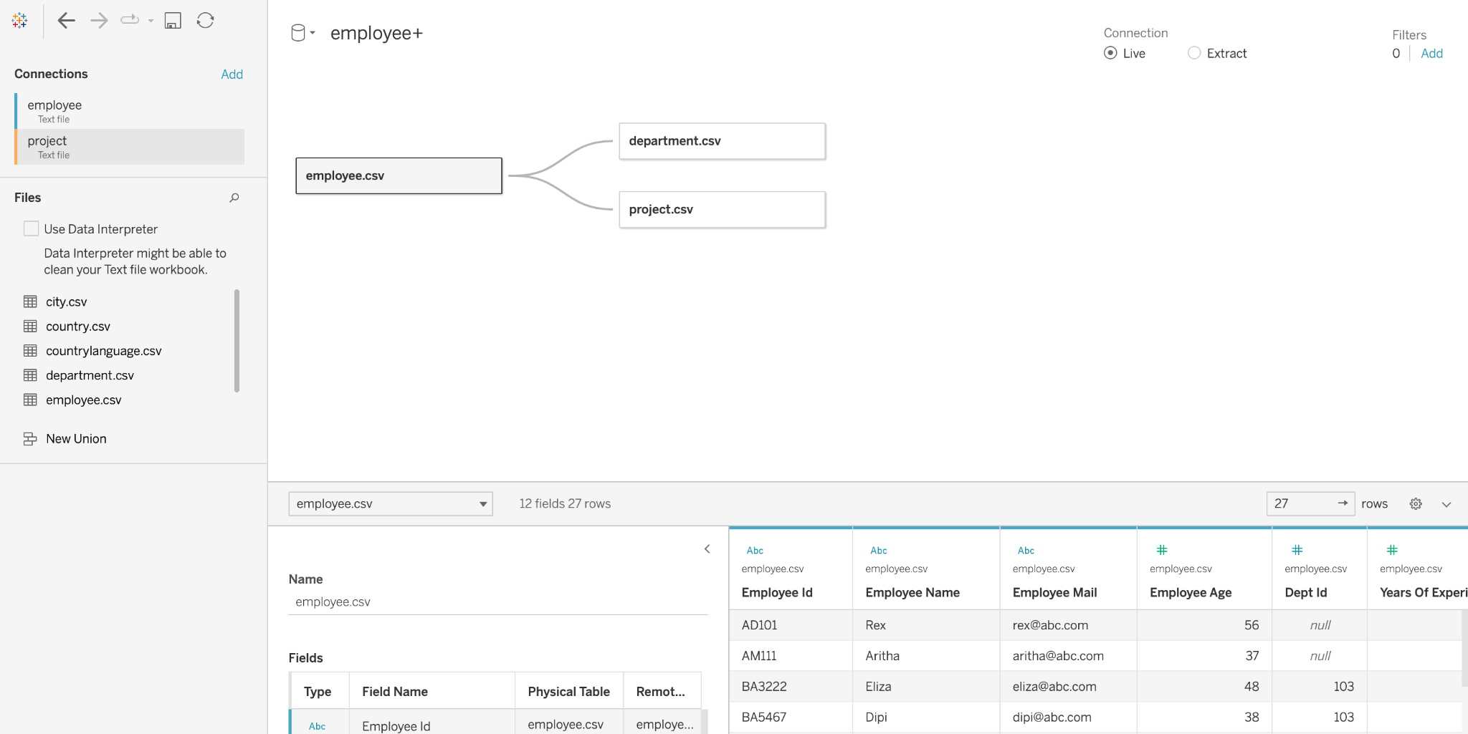

1. Your organization has made it a priority to allow relatively new and relatively seasoned employees to collaborate on projects. You want to be able to visualize the “years of experience” on a given project relative to the company average.

In a new sheet, calculate the average percentage of total_years_of_experience.

Answer:

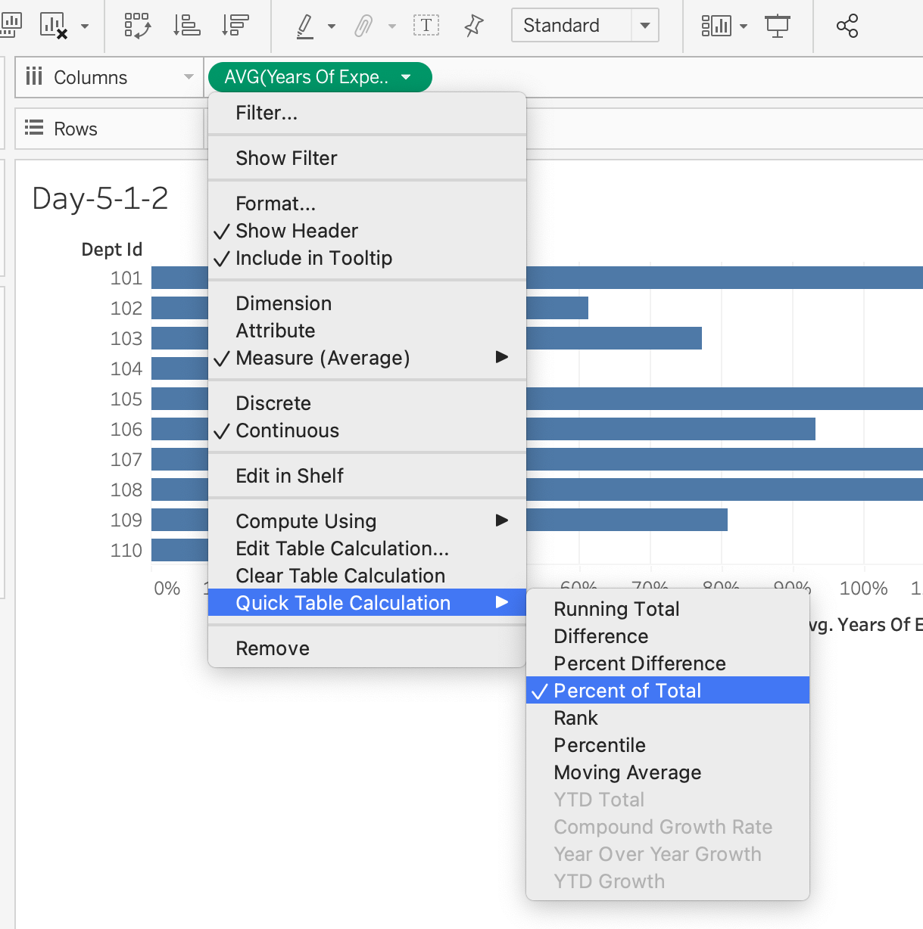

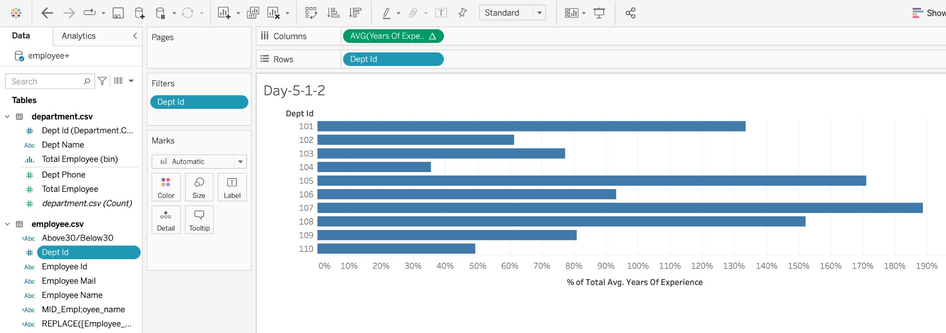

# Exercise 8

1. In a new sheet, create a treemap of the average age of employees and their department name (Hint: make sure dept_name in Columns and AVG(employee_age) are in your Rows).  
     
     
   What can you infer from the plot?

Answer: You can infer that the average age of employees in the Legal department is the highest, followed by the IT department. Finally, the HR department is the youngest.

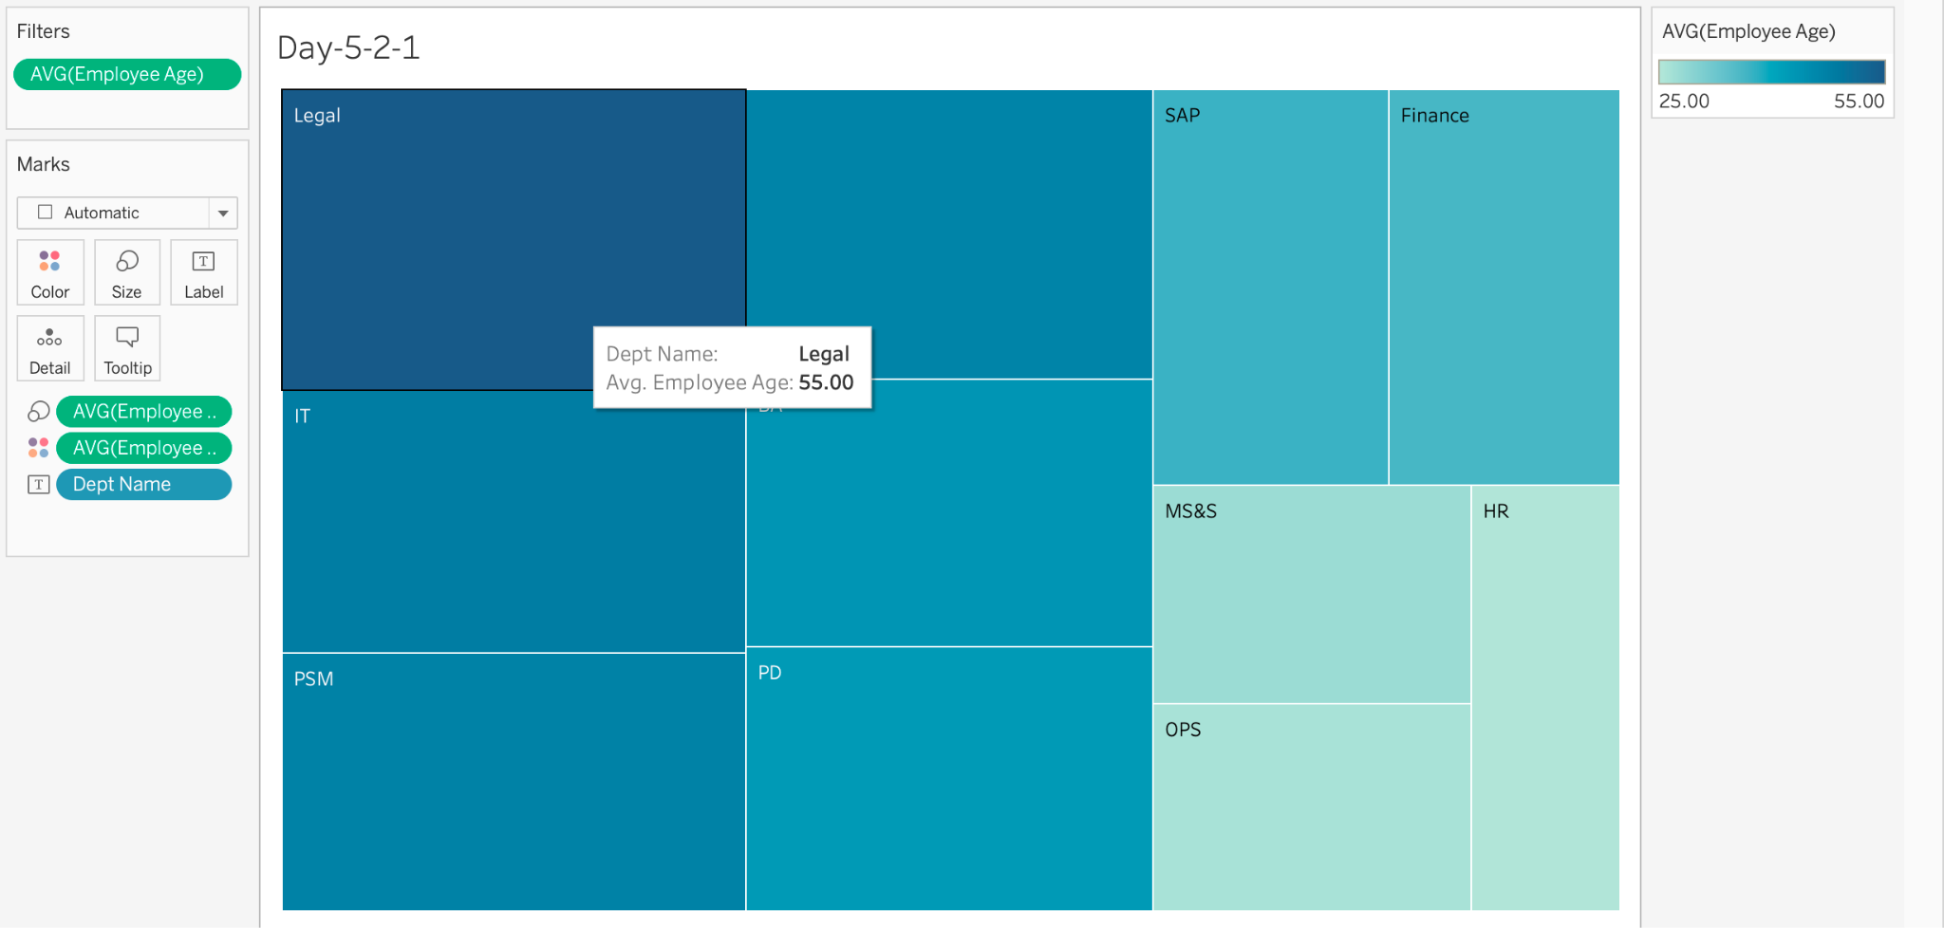

1. Create a Level of Detail (LOD) field called “**LOD_field**” that includes dept_name and average total_hours_of_work.

{INCLUDE ([dept_name]):AVG([total_hours_of_work])}

